

Data Technician

Name: Zain Nutley-Stanford
Course Date: 22nd September 2025
Table of contents
Day 1: Task 1 2
Day 2: Task 1 2
Day 2: Task 2 3
Day 2: Task 3 4
Day 3: Task 1 4
Day 3: Task 2 5
Dataset: 5
Step 1: Create a Pivot Table 5
Step 2: Use the SWITCH Function 5
Submission: 6
Day 3: Task 3 6
Day 4: Task 1 7
Course Notes 9
Additional Information 10

Day 1: Task 1

Please research and complete the below boxes on common laws and regulations that must be followed when working with customers data, use the below bulleted list to support your answers.

- What is it
- Why is it important
- Provide a real-world example of how you can follow it
- How does it impact working with data
- What could happen if you breached it

Data Protection Act | - What is it? It is a UK law that explains how organisations should fairly and safely collect, use and store personal data.  - Why is it important? It keeps personal information such as full names and bank details safe from being misused.  - Provide a real-world example of how you can follow it When signing up to a subscription platform like Netflix, the organisation must keep my contract with my payment details only for membership purposes.  - How does it impact working with data? If I work in an office, I must make sure to keep all customers names, number and personal information store safely, securely and in a private place.  - What could happen if you breached it? If the organisation was to breach this act, they would face legal actions and lose customer trust.
GDPR | - What is it? A European law that strengthens the rules on how data protection should be carried out and gives the public more control over their information.  - Why is it important? It allows the public to enquire into how much information an organisation has on them and ask them to delete it if they want.  - Provide a real-world example of how you can follow it When purchasing a product online, the company asks if they could send me marketing information and I'm have the choice to give them permission or not.  - How does it impact working with data? I must make sure that I only use the data to the extent I've been given permission too.  - What could happen if you breached it? It would lead to large fines and a loss in trust from customers
Freedom of Information Act | - What is it? This is a UK law that allows the public to ask the government or public bodies what information the can disclose to the public on request.  - Why is it important? It is important because it keeps the government and public bodies accountable and allows the public to get further insight on the organisation's operations.  - Provide a real-world example of how you can follow it A resident can contact their council and ask how they are budgeting for the year.  - How does it impact working with data? I would need to know what records are public under my employer, so if asked i could release without any issues.  - What could happen if you breached it? If i wrongly share information I could be breaching my organisations policies or I could also refuse a request of information and that can lead to my company getting scrutinised.
Computer Misuse Act | - What is it? This UK law is in place to stop the misuse of hacking, spreading viruses or using a computer to access data without permission.  - Why is it important? It protects individuals and companies from large data breaches and fraud.  - Provide a real-world example of how you can follow it If I was to use a managers credentials tom get access to private infomation, woiuld be a misuse.  - How does it impact working with data? I must follow the boundaries that have been set by my employer to make sure I operate within the act.  - What could happen if you breached it? I could lose my job, be fined or also be a cyber victim.

Day 2: Task 1

Please research and complete the following tasks within the retail-sales_dataset.xlsx document, paste a print screen into the provided boxes below:

- In the sheet ‘retail_sales_dataset’ add all available data between columns A – J into a ‘Table’. Remember to select only the data you want to convert.
- Using the dropdown menu in the ‘Age’ column, sort the data by age, ‘largest to smallest’
- Using the ‘SUM’ function, show me the commission total in cell ‘M1
- Using the ‘AVERAGE’ function, show me the average commission in cell ‘M11’

Print screen 1 | 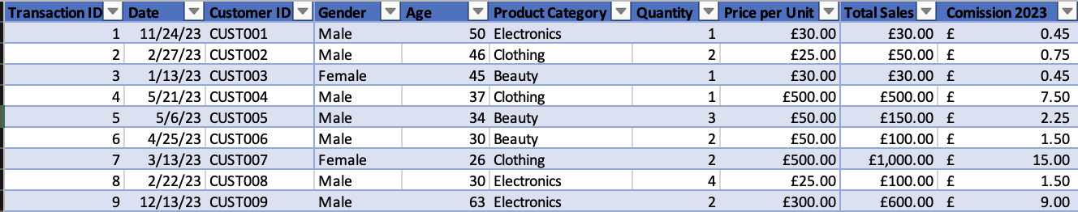
Print screen 2 | 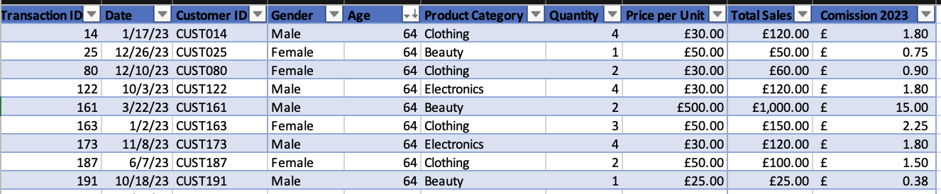
Print screen 3 | 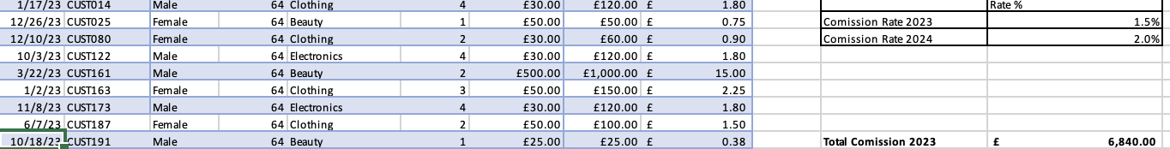
Print screen 4 | 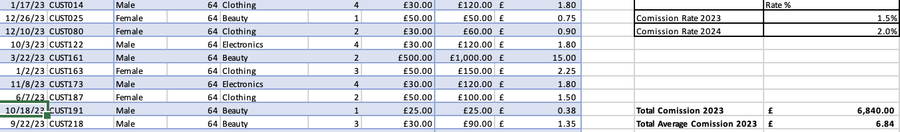

Day 2: Task 2

Please research and complete the following tasks within the retail-sales_dataset.xlsx document, paste print screens into the provided box below:


Print screen 1 | 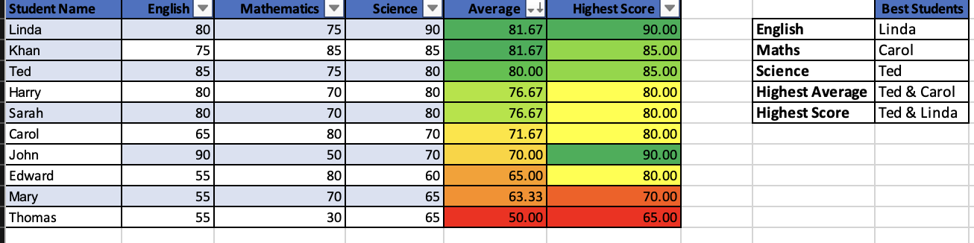

Day 2: Task 3

Using the skills developed today, have some fun with the data set you have imported. Paste your work below and enjoy!

Print screen 1

Day 3: Task 1

Please download the dataset ‘Day_3_Task_1_Bike_Sales_Pivot_Lab.xlsx’ from here.

The lab instructions can be found here. Do not worry if you do not complete the lab, just working with data and playing with the pivot table will be good experience.

Please paste your final pivot table below and complete the reflection questions:

Print screen 1 | 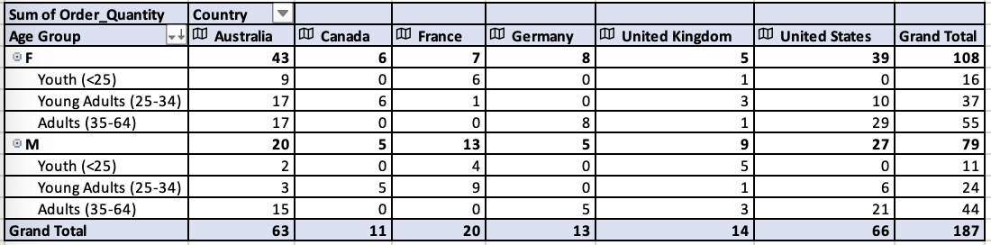
In which markets does Germany have customers? | Germany only has customers in both the male and female adult (35-64) market.
What country has sales in all markets? | Australia is the country with sales in all markets.
What are the most profitable markets by country, age group, and gender? | The markets that show high profits are the United States and Australia. United States has a grand total of 66 orders, followed by Australia with 63 orders.  The most profitable age group is the female adults (35-64).  The most profitable gender is Female, as they have a total of 108 orders.
Any other findings? | Canada is the country with the least orders with a total sum of 11.  The Male youth (<25) is the market with the lowest sum of orders.

Day 3: Task 2

The dataset below tracks the sales performance of different products in various counties in England. Please paste the dataset into a blank Excel workbook. Your task is to:
- Create a Pivot Table to summarise the data by county and product.
- Use the SWITCH function to categorise products based on their sales volume.

Dataset:
County | Product | Sales Volume
Yorkshire | Laptops | 500
Yorkshire | Smartphones | 200
Cornwall | Laptops | 700
Cornwall | Printers | 400
Lancashire | Smartphones | 150
Lancashire | Laptops | 600
Essex | Printers | 800
Essex | Smartphones | 300
Durham | Laptops | 250
Durham | Printers | 300
Greater Manchester | Smartphones | 600
Greater Manchester | Laptops | 400

Step 1: Create a Pivot Table
- Select the dataset (columns A to C).
- Insert a Pivot Table to summarise the data by County in the rows and Products in the columns. Use Sales Volume as the value to be summarised.

Step 2: Use the SWITCH Function
In a new column next to your data, use the SWITCH function to categorise products based on Sales Volume as follows:
  - For sales greater than 600: "High"
  - For sales between 300 and 600: "Medium"
  - For sales less than 300: "Low"
SWITCH Function Example:
=SWITCH(TRUE, C2 > 600, "High", C2 >= 300, "Medium", "Low")
- Apply this formula to each row, and check if the products are categorised correctly.
- In ‘Sales Volume’ you need to remove the space after each amount
- Confirm the data type is numerical

Submission:
- A completed Pivot Table summarising sales by county and product.
- A new column in the dataset categorising products by sales volume using the SWITCH function.
  - Please paste your completed work below

Print screen 1 | 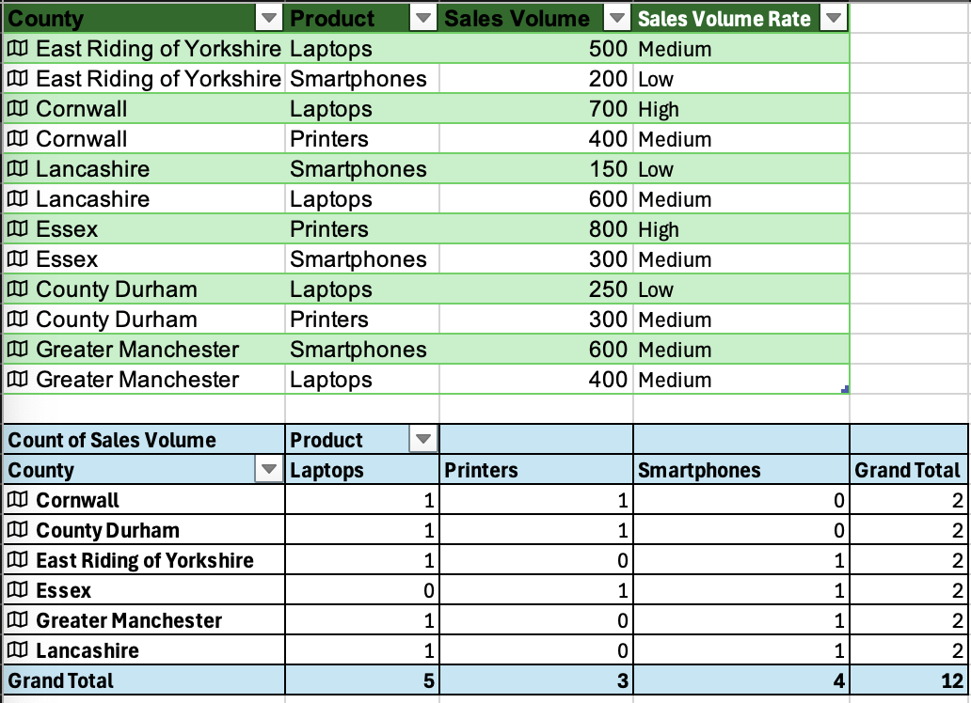

Day 3: Task 3

Please download the dataset ‘Day_3_Task_3_Bike_Sales_Visualisations_Lab.xlsx’ from here.

The lab instructions can be found here. Do not worry if you do not complete the lab, just working with data and playing with the charts will be good experience.

Please paste your results below:

Print screen 1

Day 4: Task 1

You have been asked to deliver your analysis findings to the board of directors, within your analysis you have identified that customers are leaving your company at the 12-month point, this is typically when they receive their renewal price.

Conduct research and complete the below questions:

How would you prepare for the delivery?
What tools would you use for the delivery?
What is prospecting and why would you complete this before your delivery?
Tell me best practices for public speaking and providing updates to senior leaders
What will you show the board in your delivery?
How will you articulate the changes that are needed?
Provide a list of online resources and videos that will support your preparation for public speaking
Evaluate tools that provide visualisation.

Tell me what they are.

Tell me what you would choose when delivering your presentation and why

Course Notes

It is recommended to take notes from the course, use the space below to do so, or use the revision guide shared with the class:

Additional Information

We have included a range of additional links to further resources and information that you may find useful, these can be found within your revision guide.

END OF WORKBOOK

Please check through your work thoroughly before submitting and update the table of contents if required.

Please send your completed work booklet to your trainer.

